Memorial Seminar dedicated to the centenary of the birth of
Fyodor L. Shapiro (1915 – 1973)
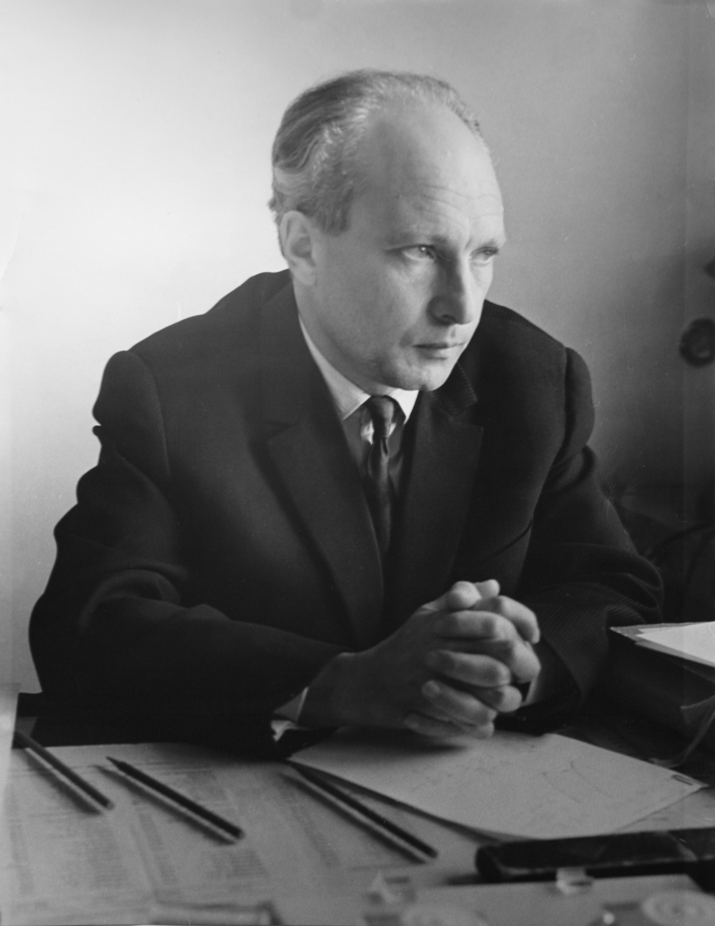
www: https://indico-new.jinr.ru/event/shapiro100

Dubna, Russia, April 6 – 7, 2015

FRANK LABORATORY OF NEUTRON PHYSICS
JOINT INSTITUTE FOR NUCLEAR RESEARCH

FIRST CIRCULAR

seminar information
On April 6, 2015 it will be 100 years since the birth of the outstanding Soviet physicist Fyodor L. Shapiro (1915 - 1973), one of the founders of the Frank Laboratory of Neutron Physics (FLNP) of the Joint Institute for Nuclear Research (JINR).
The FLNP and JINR are organizing the Memorial Seminar dedicated to the centenary of the birth of the Corresponding Member of the USSR Academy of Sciences Fyodor L. Shapiro to be held on April 6-7, 2015 in Dubna. The expected number of participants is about 100.
The scientific and memorial reports of the FLNP leading physicists about the contribution of F.L.Shapiro to the formation and development of the scientific program of the Laboratory will be presented as well as reports of the world’s leading experts about the current state of the art in the research areas that F.L.Shapiro pioneered and worked on.
The invited speakers are:
V.L.Aksenov NRC KI PNPI
A.M.Balagurov JINR
L.Cser WPRC
P.Geltenbort ILL
V.A.Matveev JINR
V.V.Nesvizhevsky ILL
E.P.Shabalin JINR
V.N.Shvetsov JINR
A.Steyerl URI
A.Stoica ORNL
A.V.Strelkov JINR

The Seminar language is ENGLISH.

A poster session will be included in the program of the Seminar and we invite young scientists as well as F.L.Shapiro fellowship winners of the previous years to present their recent works in the field of neutron physics. The Seminar proceedings (twelve pages for invited talks and eight pages for poster presentations) will be published by the JINR Publishing Department.
The excursion to FLNP and visit to F.L.Shapiro’s burial place in the Donskoy cemetery will be organized during the second day of the Seminar.
An exhibition dedicated to the memory of F.L.Shapiro will take place during the Seminar.

REGISTRATION
The registration of participants will be open via internet from December 15. The participants are kindly requested to fill out the registration form as soon as possible for reservation of accommodation and other arrangements.

REGISTRATION FEE
There is no REGISTRATION FEE.

TRANSPORTATION

We kindly ask you to inform us about your arrival and departure details. The information should be sent to the Seminar coordinator Mrs. Tatiana Donskova not later than April 1 to organize your transfer from Moscow airport to Dubna.

ORGAnizing committee
V.L.Aksenov - Co-chairman
V.A.Matveev - Co-chairman
E.V.Lychagin - Scientific Secretary

T.S.Donskova - Seminar Coordinator
A.M.Balagurov
I.A.Bobrikov
D.Chudoba
O.Culicov
V.I.Furman
S.V.Kozenkov
N.Kucerka
E.P.Shabalin
V.N.Shvetsov
A.V.Strelkov

SECRETARIAT
N.A.Malysheva
E.S.Kopach

Contact addressES
Egor Valer’evich Lychagin  Frank Laboratory of Neutron Physics  Joint Institute for Nuclear Research  141980 Dubna, Moscow Region, Russia  Tel.: (+7-496-21)62428  Fax: (+7-496-21)65429  Telex: 911621 DUBNA SU  E-mail: lychag@nf.jinr.ru  www: https://indico-new.jinr.ru/event/shapiro100 | Tatiana Sergeevna DONSKOVA  International Department  Joint Institute for Nuclear Research  141980 Dubna, Moscow Region, Russia  Tel.: (7-496-21)63448  Fax: (7-496-21)65891, 65599  Telex: 911621 DUBNA SU  E-mail: Tatyana.Donskova@jinr.ru

